Udacity

Data Analyst Nanodegree

Project 1 : Exploring Weather Trends

By

Ruchi Agrawal

# Steps taken to prepare data:

## Extracting data from database

1. First, I used SQL queries to check the nearest city option available. I chose Pune from the list.

Query: select * from city_list where country = ’India’;

1. Then I used SQL queries to visualize if both global and Pune’s data are available for same years. Here, I found that data for Pune city is not available for some of the years.

Query 1: select * from city_data where city = ‘Pune’ and country = ‘India’

Query 2: select * from global_data

1. For comparison, I renamed local and global temp columns

Query 1: ALTER TABLE global_data RENAME COLUMN avg_temp to global_avg_temp;

Query 2: ALTER TABLE city_data RENAME COLUMN avg_temp to local_avg_temp;

1. Now I extracted global and local data for the years which is available for Pune city

Query: select global_data.year, city_data.city, global_data.global_avg_temp, city_data.local_avg_temp FROM global_data, city_data WHERE ((global_data.year=city_data.year) and (city_data.city = 'Pune' and city_data.country = 'India'))

1. Once the csv file was downloaded, I opened it in Excel and calculated moving average for both local and global temperatures. I calculated moving average for 7 years.

Formula used for global_avg_temp: =AVERAGE($C2:$C8) copied till last row

Formula used for local_avg_temp: =AVERAGE($D2:$D8) copied till last row

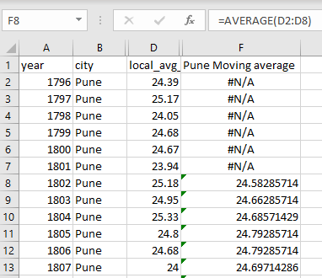 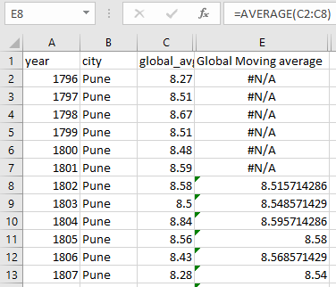

1. Then I plotted line charts for global and local temperatures.



## Chart:

## Observations:

1. Global average temperature trend started increasing slightly from 1980. Pune’s average temperature started increasing after 1998.
2. From year 1862 to 1869, Pune’s average temperature dropped slightly even though global average moving temperature remained almost the same.
3. From year 1847 to year 1980, the average global temperature varied slightly while for Pune, the change in average temperature was significantly higher.
4. From 1870 to 1885, the curve’s of Pune’s temperature trends maintains higher variance when compared to global temperature in the line chart. Hence, we can conclude that Pune was hotter as compared to global average temperature during that time.
5. In 1803, the difference between the moving average temperature of Pune and global is:

24.66-8.55 = 16.11

In 2013, the difference between the moving average temperature of Pune and global is:

* + - 1. 15.96

This says that overall temperature difference between Pune and global temperatures has decreased slightly in 2013 as compared to 1803.

1. The overall trends of Pune and global temperatures are increasing gradually day by day.